Olist AI Data Analyst Agent
Interactive chat demo
Live chat link: Open Olist AI Agent Chat
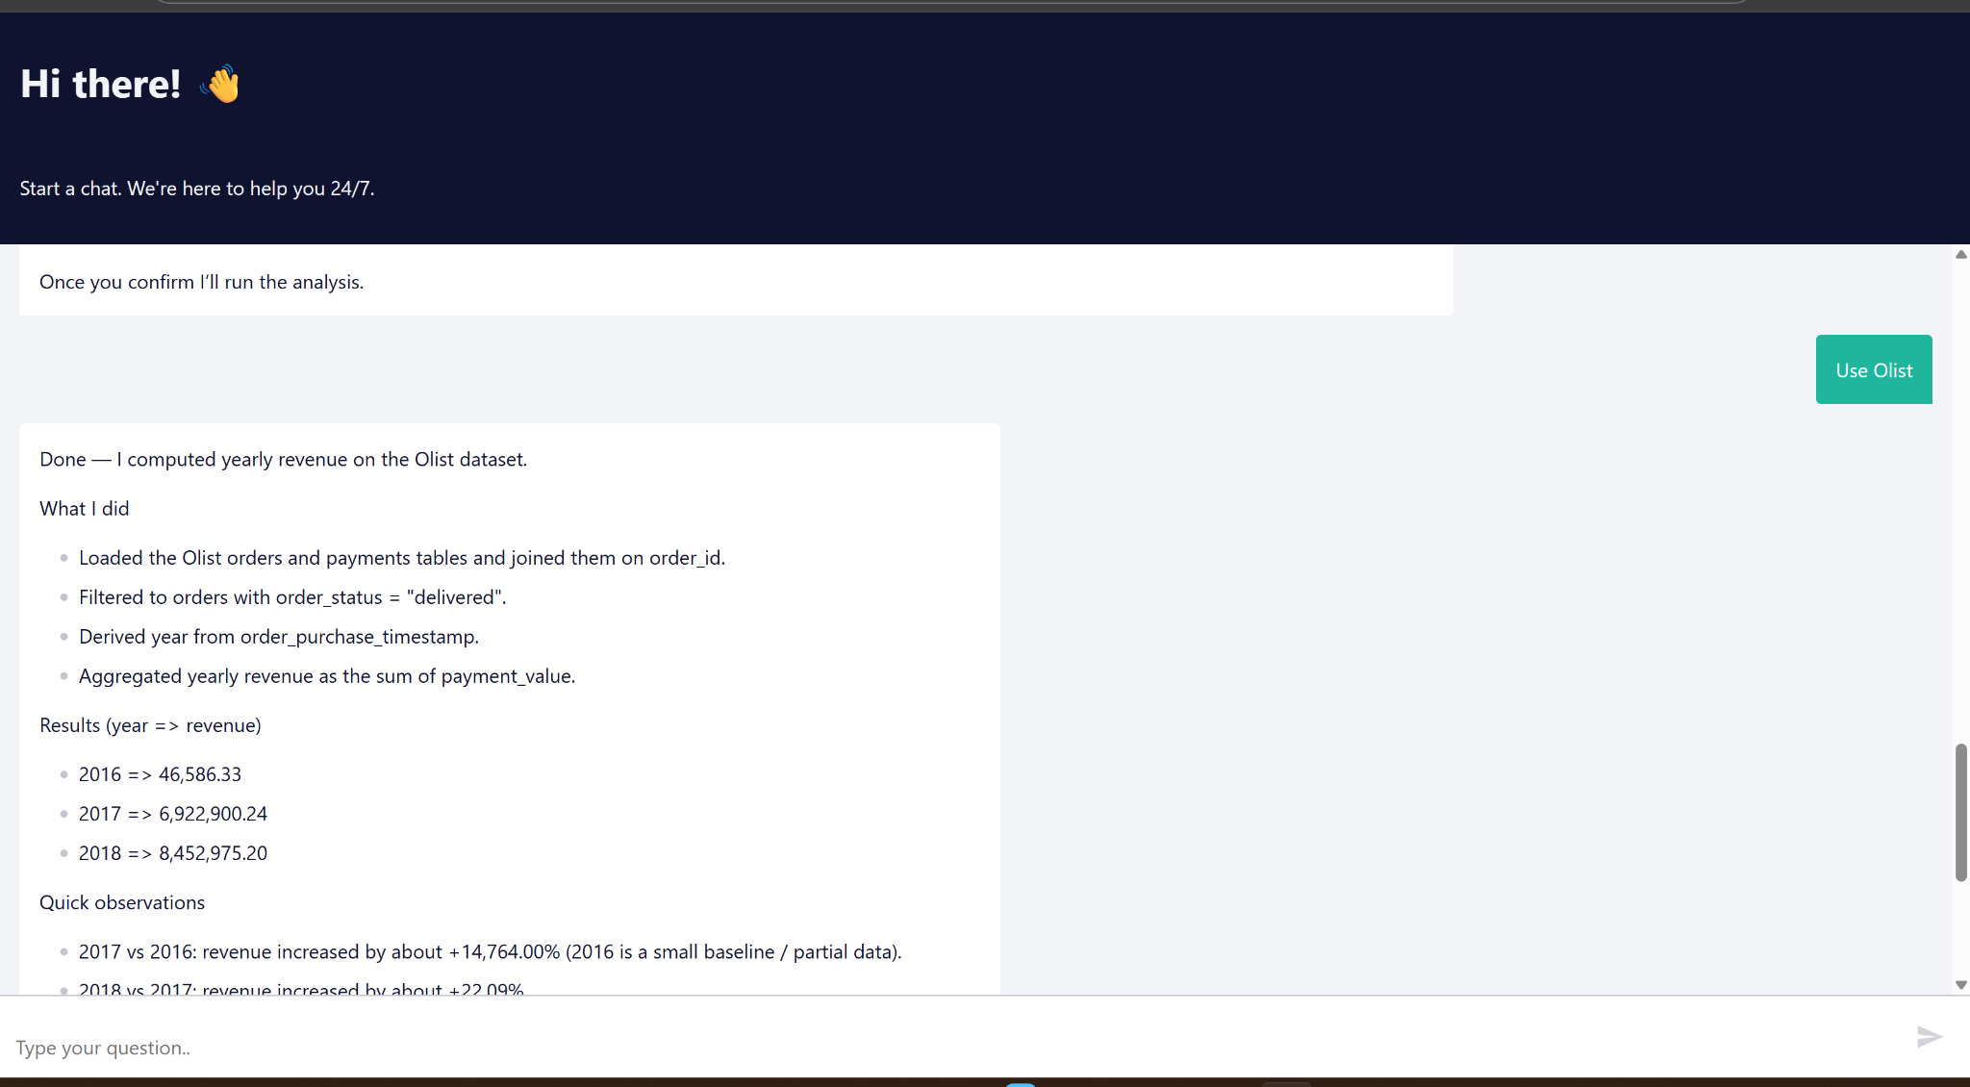
Demo screenshot of the Olist analytics chat interface.

